**

Copyright for test papers and marking guides remains with *West Australian Test Papers.*

Test papers may only be reproduced within the purchasing school according to the advertised Conditions of Sale.

Test papers should be withdrawn after use and stored securely in the school until Friday 15th June 2018.

**MATHEMATICS**

**METHODS**

**UNIT 3**

**Semester One**

**2018**

**SOLUTIONS**

***Calculator−free Solutions***

1.. 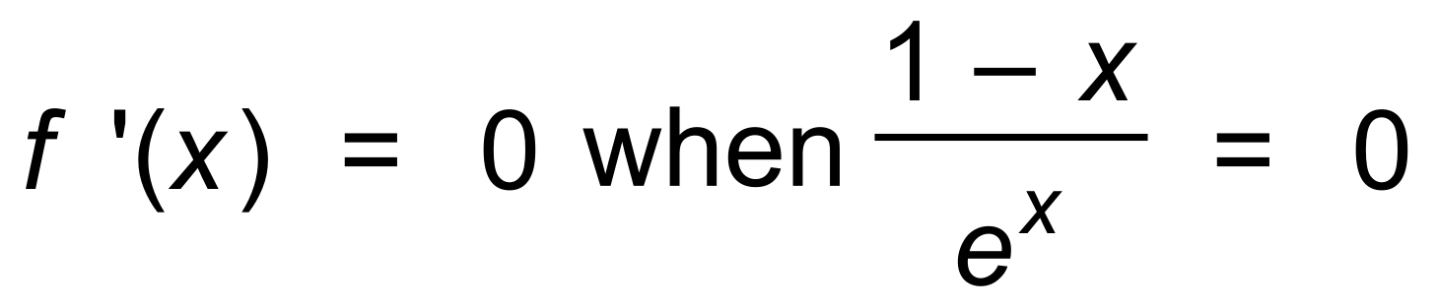 ✓

∴ x = 1 ✓

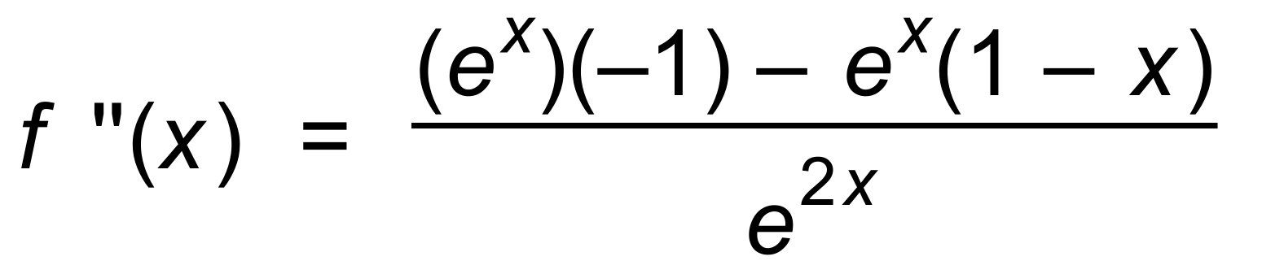 ✓

Since f ′′(1) < 0, then maximum ✓

[4]

2. 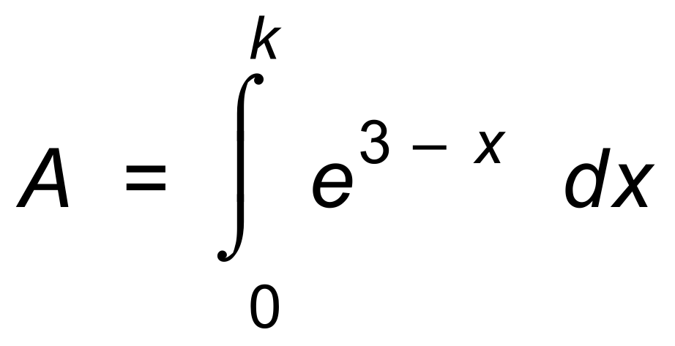 ✓

∴ 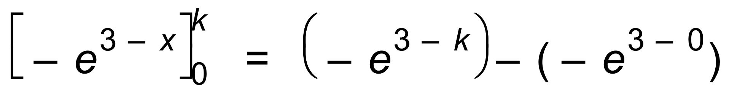 ✓

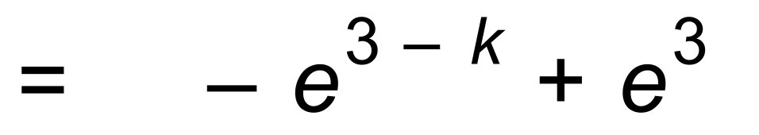 ✓

If 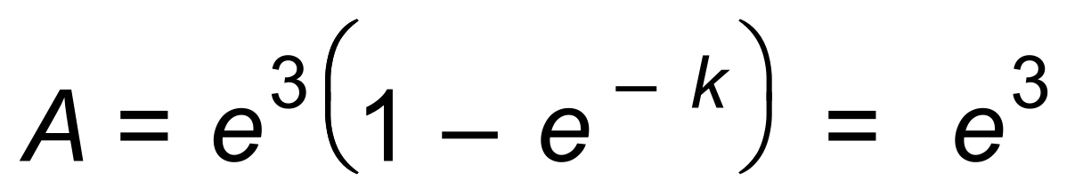 then 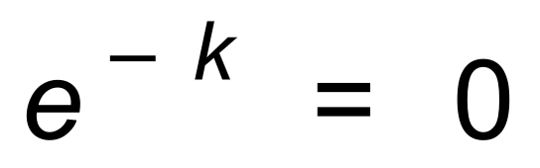, which is impossible. ✓

If 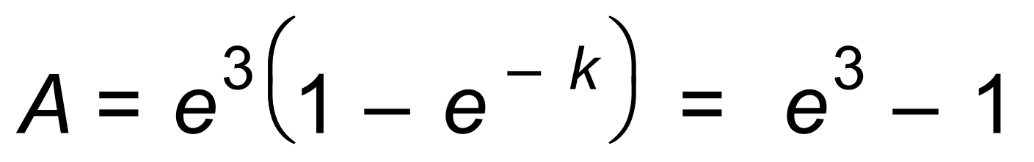 ✓

∴ k = 3 ✓ [6]

3. (a) Stationary point occurs when 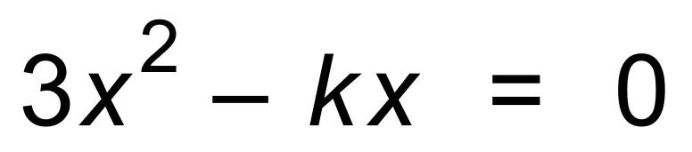

∴  ✓

∴ k = 18 ✓

(b) 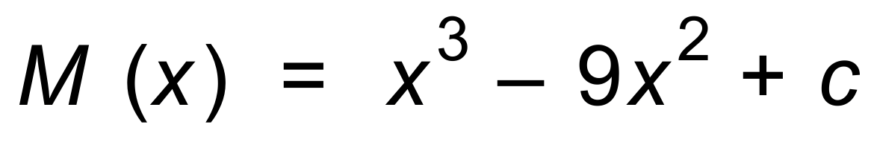 ✓

Since  ✓

∴ 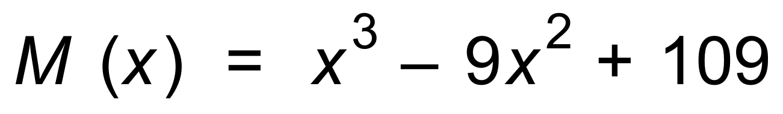 ✓

∴ Vertical intercept = 109 ✓ [6]

4. (a) 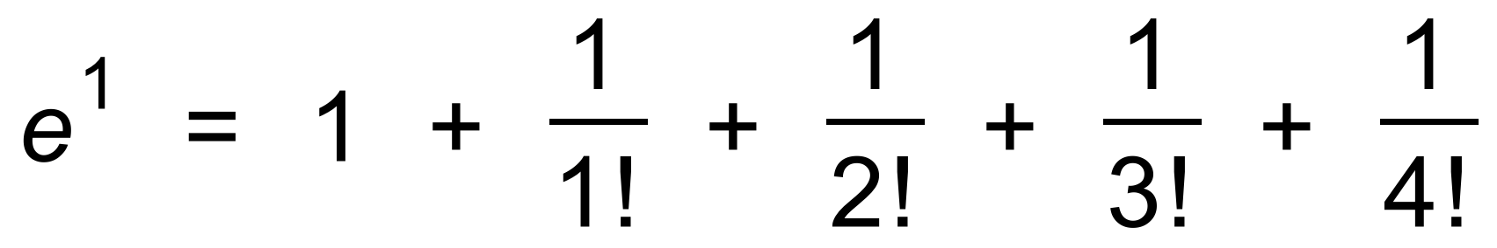 ✓

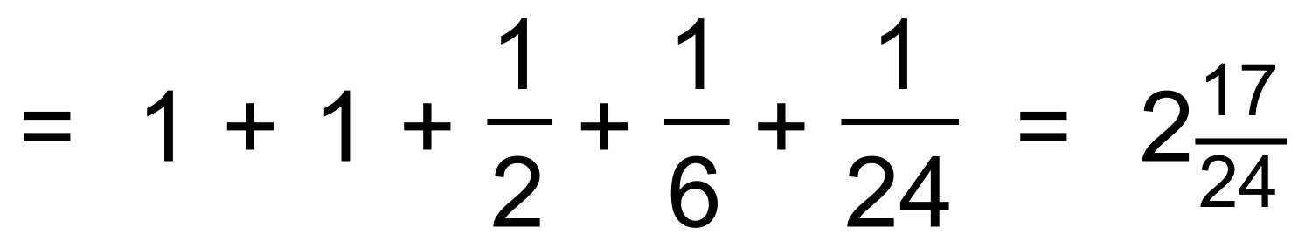 ✓

(b) 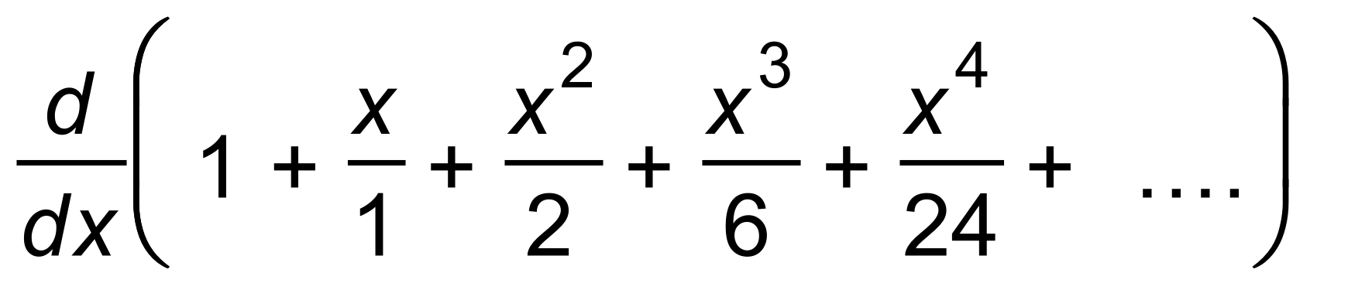

= 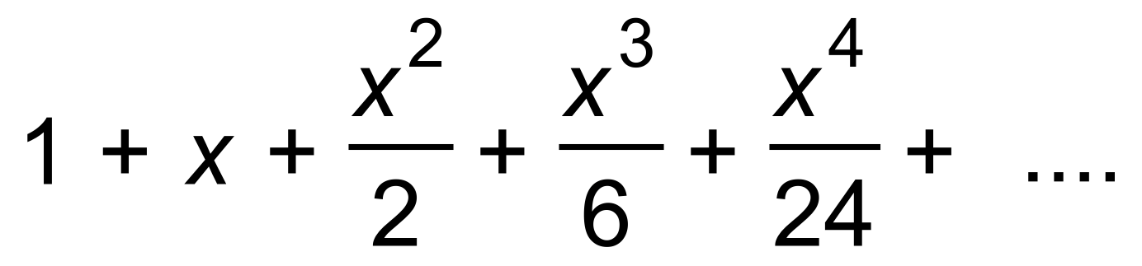 ✓

= 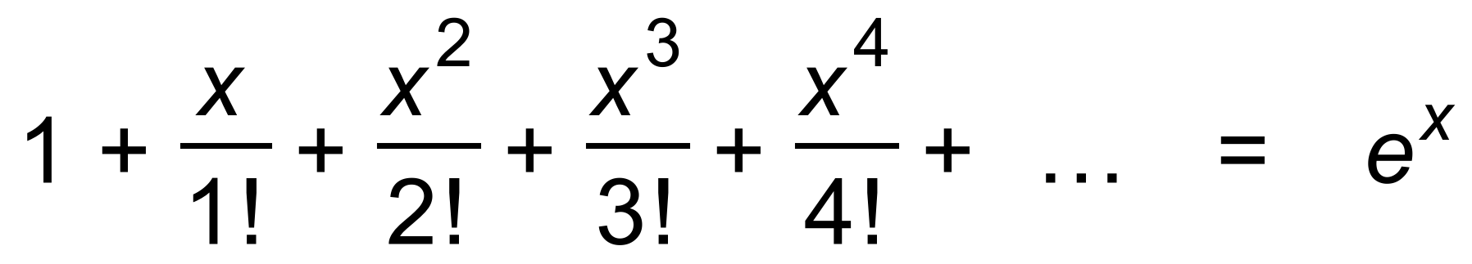 ✓ [4]

5. (a) 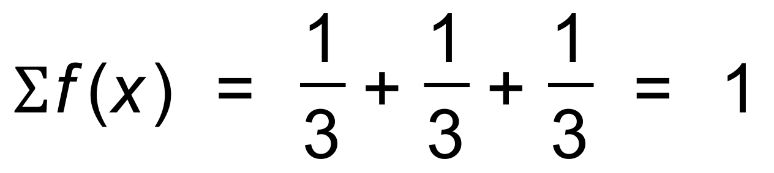 ✓

and 0  f (x) 0 for all x ✓

∴ PDF

(b) 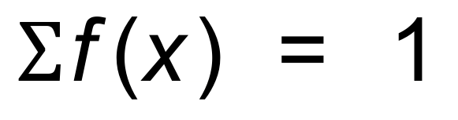 ✓

and 0  f (x) 0 for all x ✓

∴ PDF

(c) Since 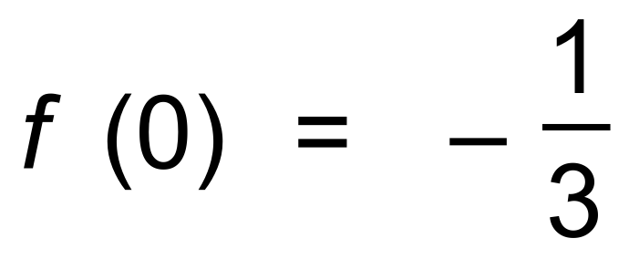

f (x) is not greater than or equal to 0 for all x ✓

∴ Not PDF ✓ [6]

6. (a) Since PDF  ✓

(b) 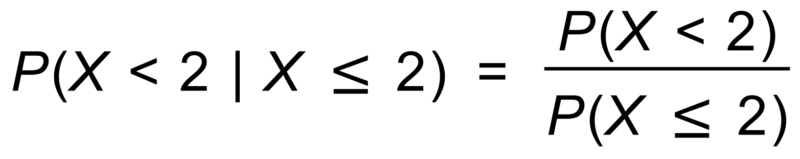 ✓

= 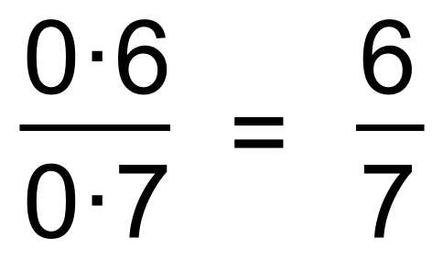 ✓

(c) E(X) = 0 + 0.1 + 0.2 + 0.3 + 0.8 = 1.4 ✓✓

(d) Variance = (0 + 1 x 0.1 + 4 x 0.1 + 9 x 0.1 + 16 x 0.2) − 1.42 ✓✓

= 0.1 + 0.4 + 0.9 + 3.2 − 1.96 = 2.64 ✓ [8]

7. E(Y) = 2E(X) + 3 = 8

∴ m = 2.5 ✓

VAR(Y) = 4VAR(X) = 20

∴ v = 5 ✓✓ [3]

8. (a) 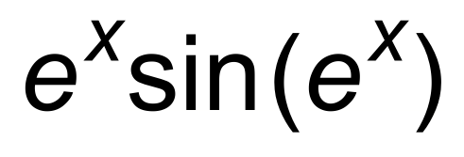 ✓✓

(b) 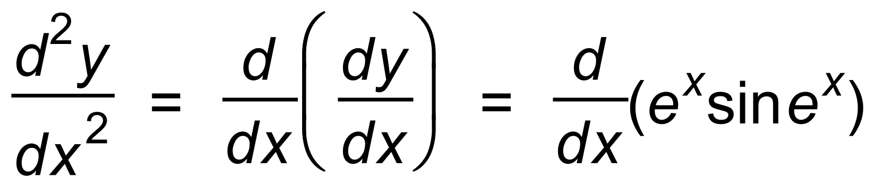 ✓

= 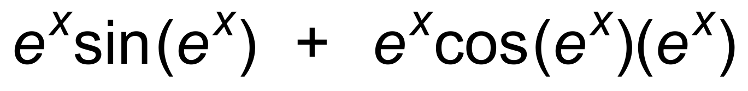 ✓✓ [5]

9. (a) 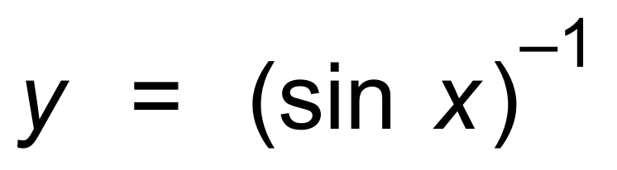

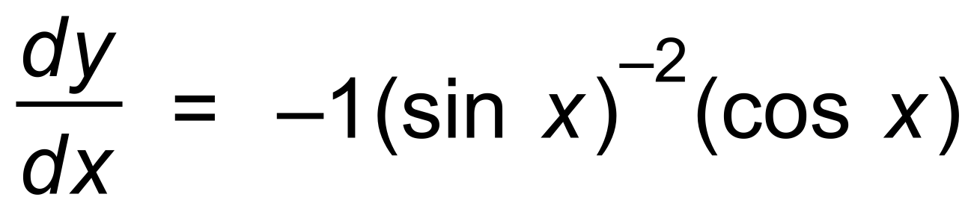 ✓

= 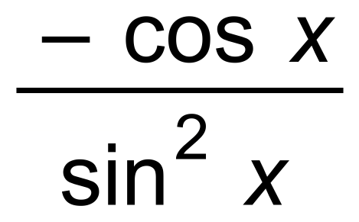 ✓

(b) 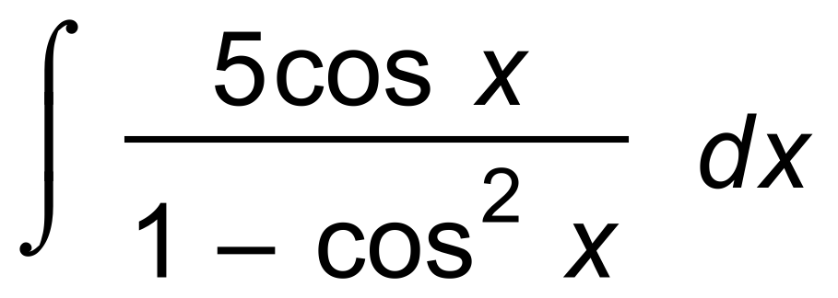

= 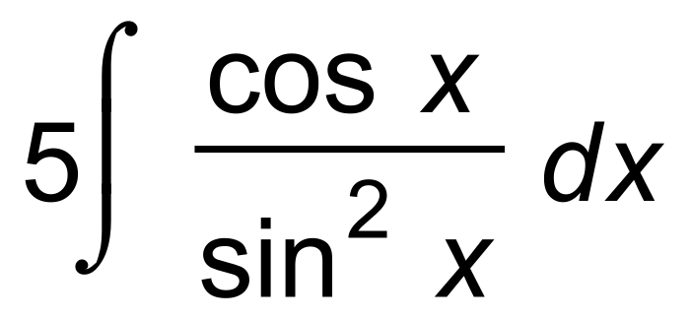 ✓

= 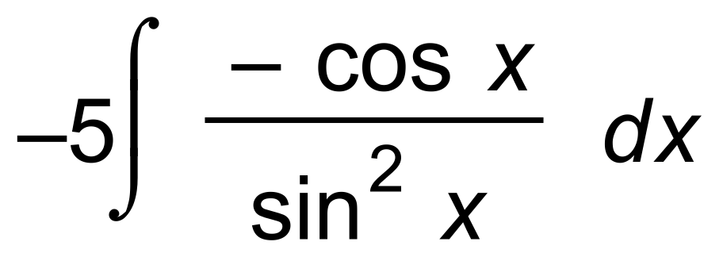 ✓

= 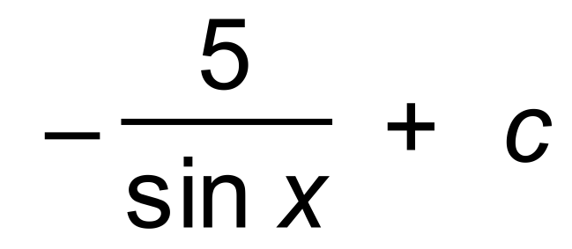 ✓ [5]

10. (a) 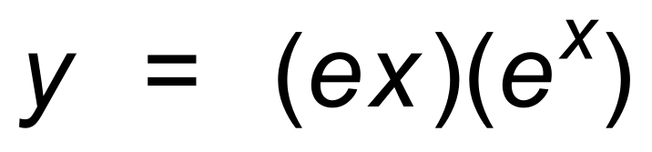

∴ 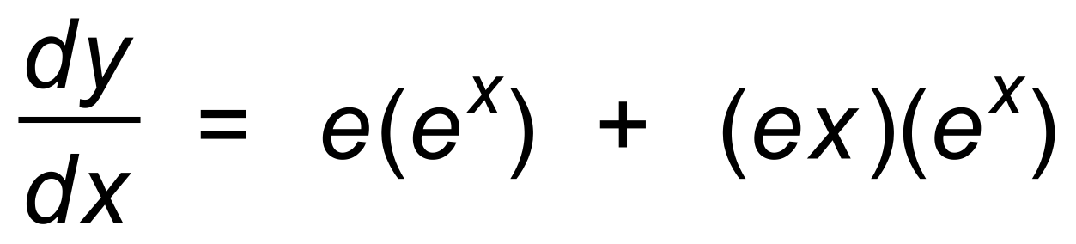 ✓

∴ = 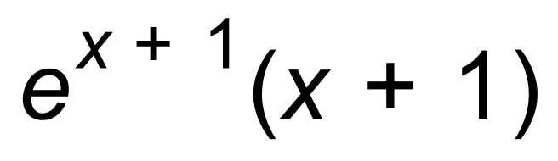 ✓

(b) 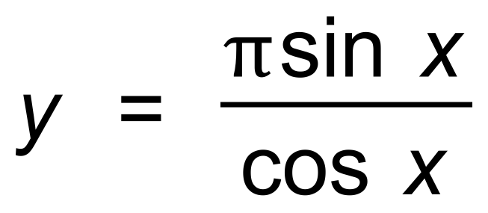

∴ 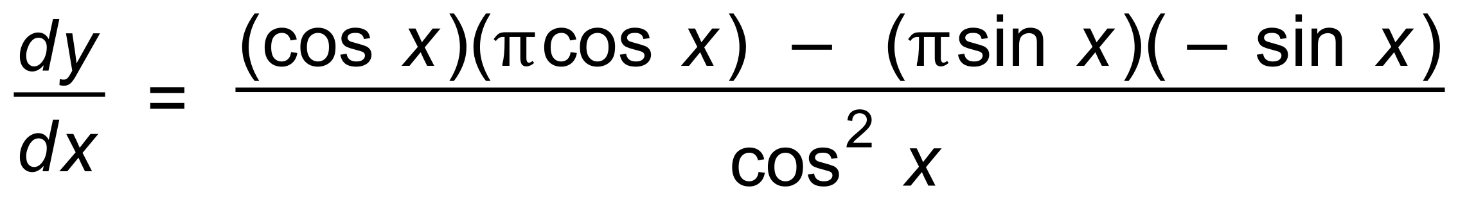 ✓

= 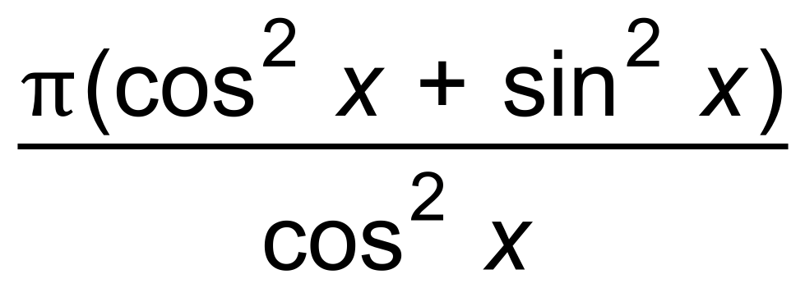 ✓

= 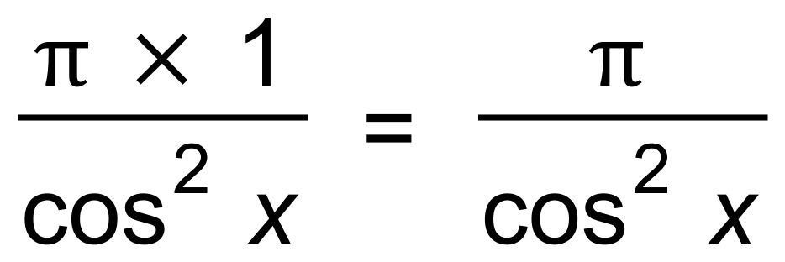 ✓ [5]

***Calculator−assumed Solutions***

11. (a) 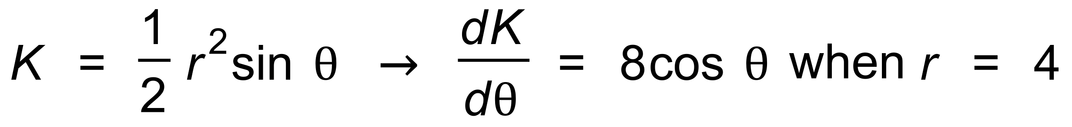 ✓

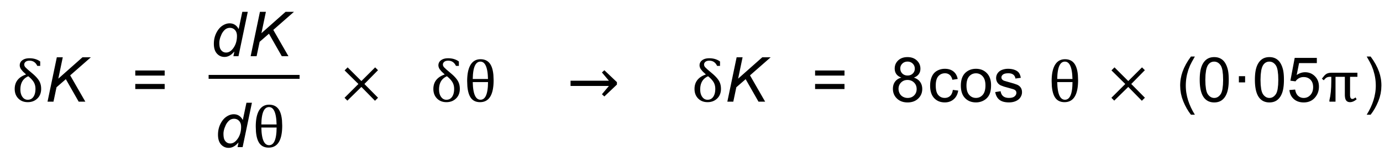 ✓

∴ 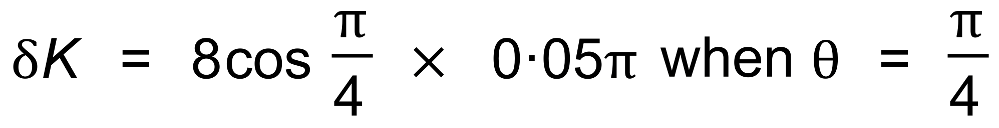

∴ 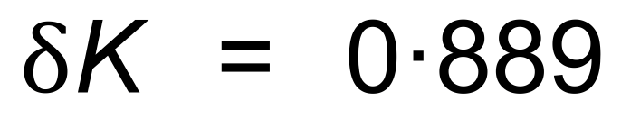 ✓

(b) 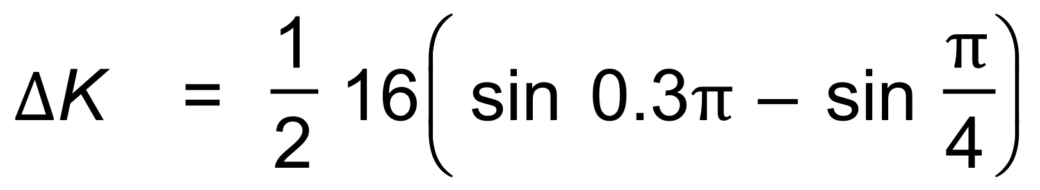

∴ 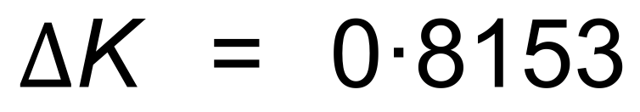 ✓

∴  ✓ [5]

12. (−3, 0) → 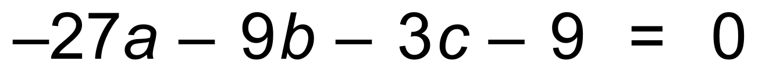 ✓

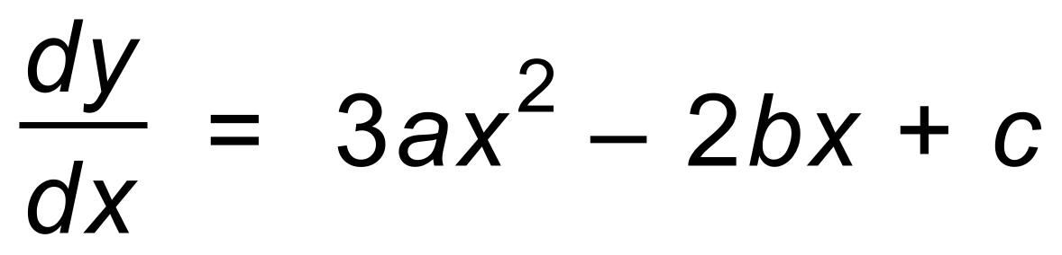 ✓

 ✓

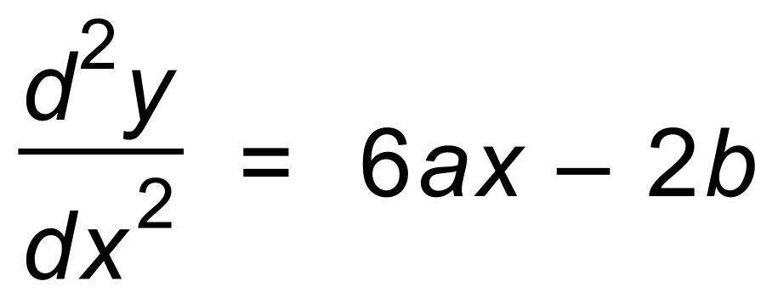 ✓

POI 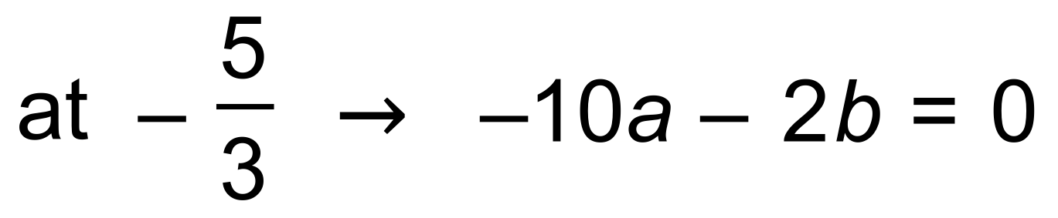 ✓

∴ Using calc  ✓✓ [7]

13. (a) 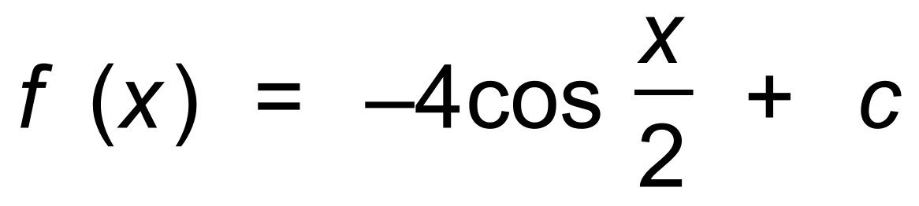 ✓

∴ 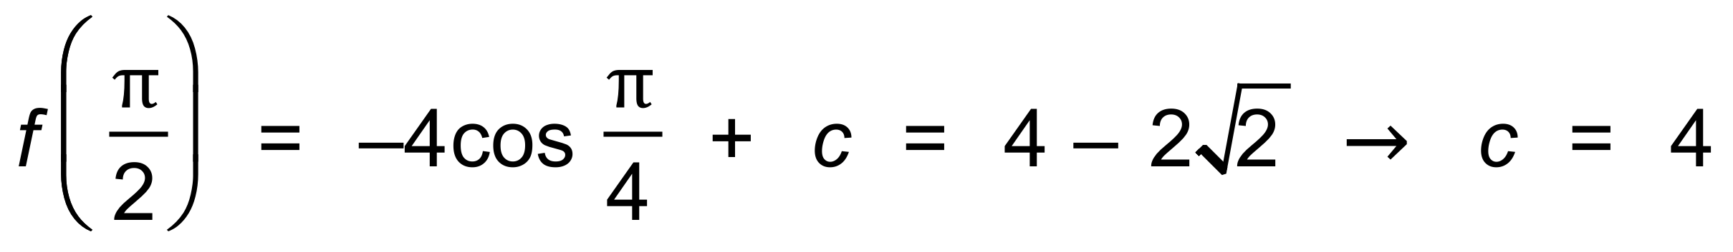 ✓

∴ 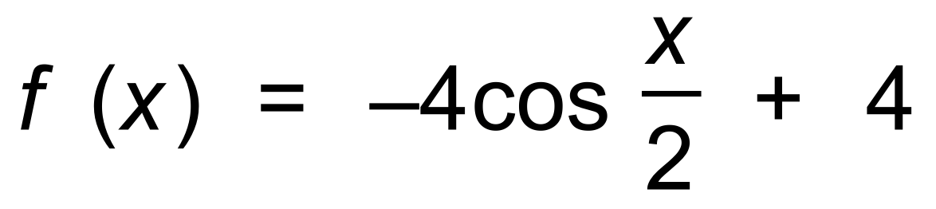 ✓

(b) 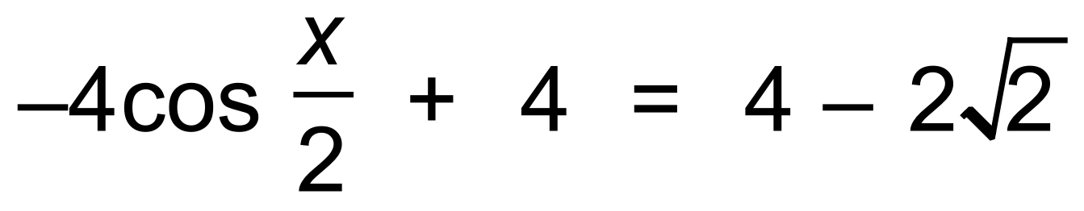

∴ 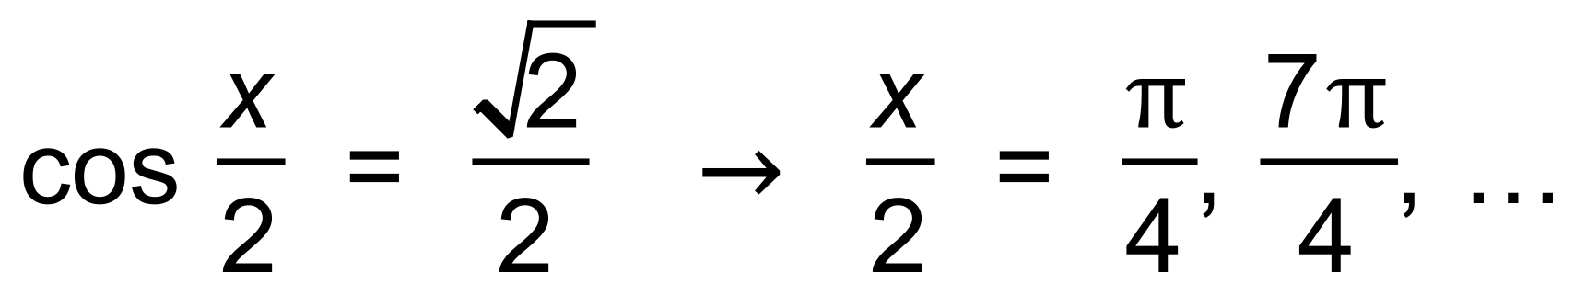 ✓✓

∴ Next time is 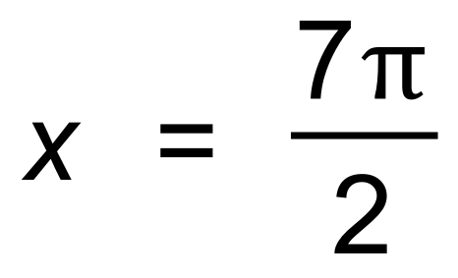 ✓ [6]

14. (a) (i) 0 + 1 + (−5) + 4 = 0 ✓✓

(ii) −3 + 1 + (−5) + 4 = −3 ✓✓

(iii) 1 + 5 + 4 = 10 ✓✓

(b) (i) 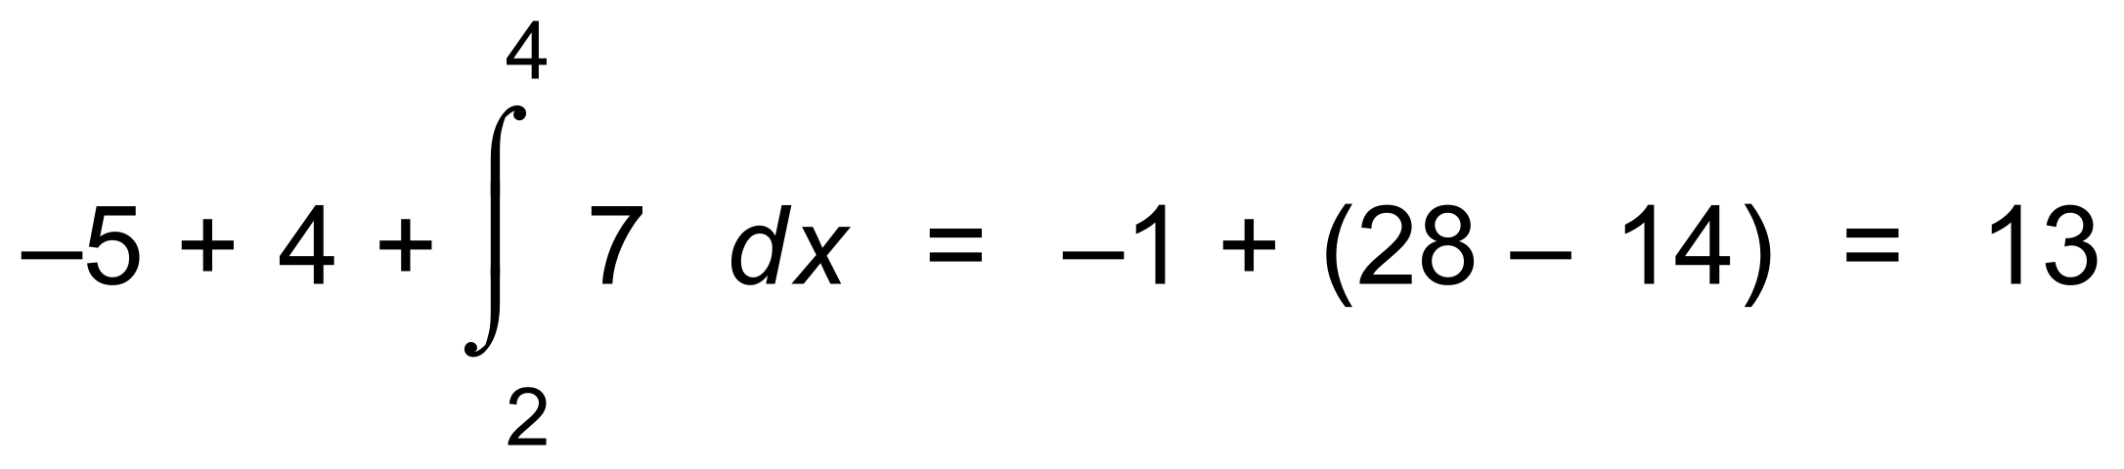 ✓✓

(ii) 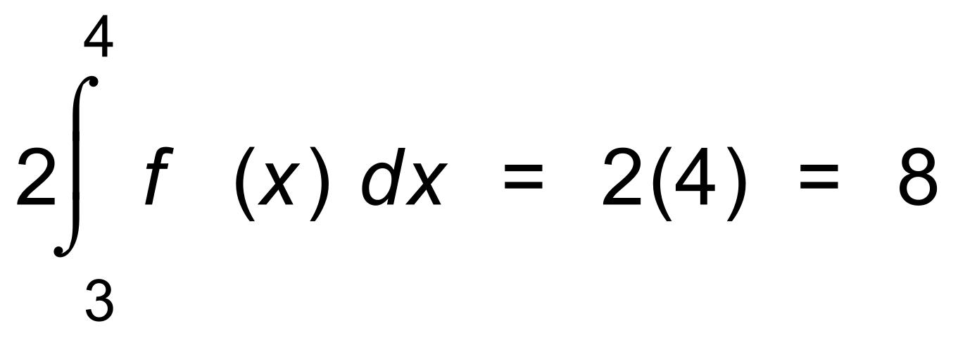 ✓✓[10]

15. (a) (i)  ✓

∴ 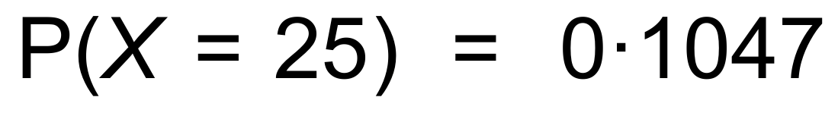 ✓✓

(ii) 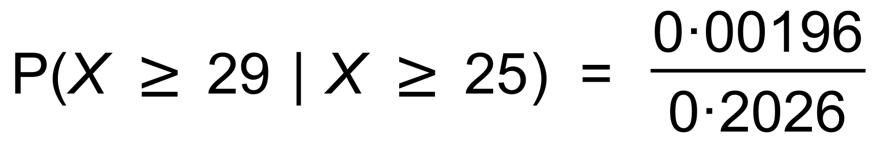 ✓✓

= 0.00967 ✓

(b) 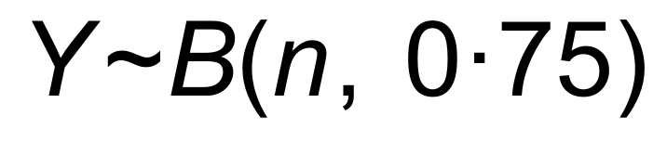 where *Y* is the number who graduated out of *n*

∴  using trial and error ✓✓✓

|  |  |
| --- | --- |
| n | Y |
| 18 | 0.981 |
| 19 | 0.991 |
| 20 | 0.996 |

(c) (i) 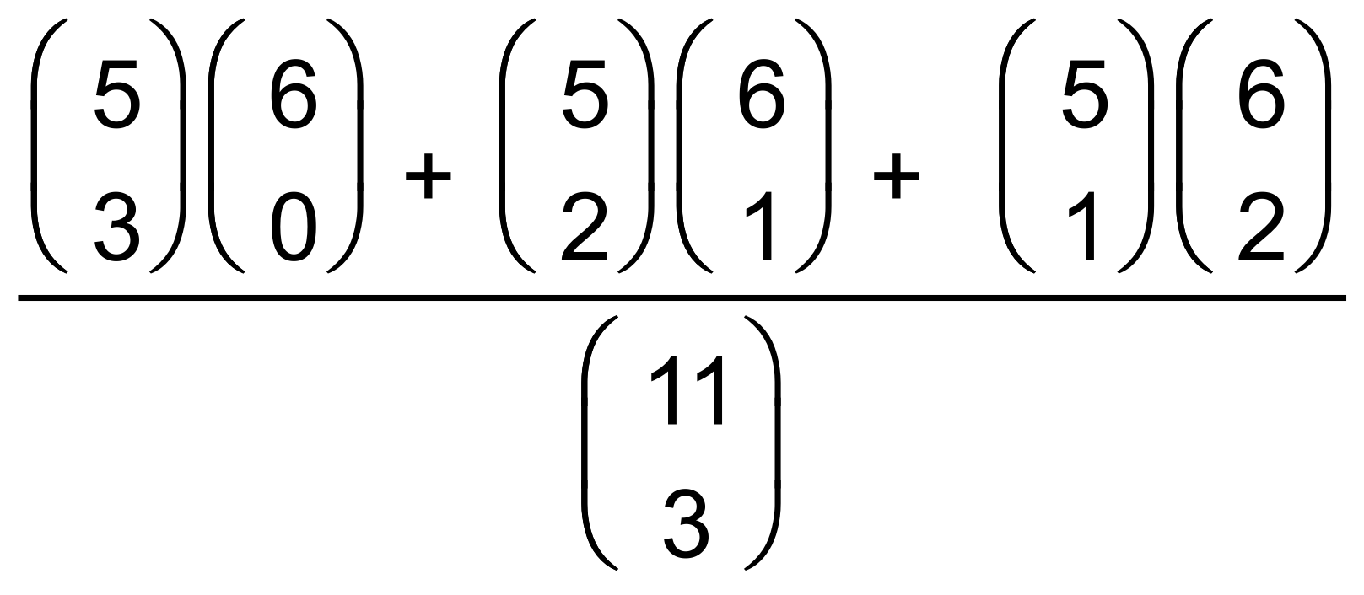 ✓✓

= 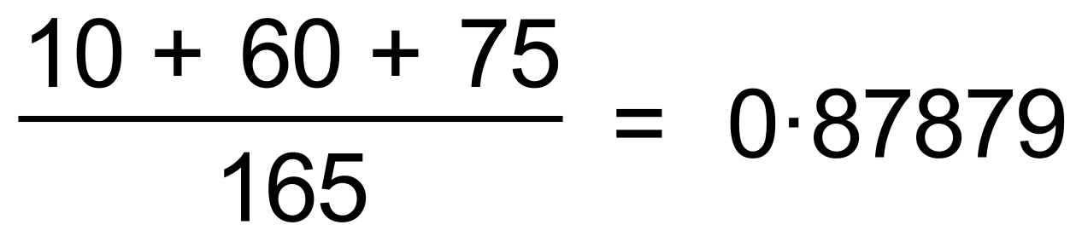 ✓

(ii) 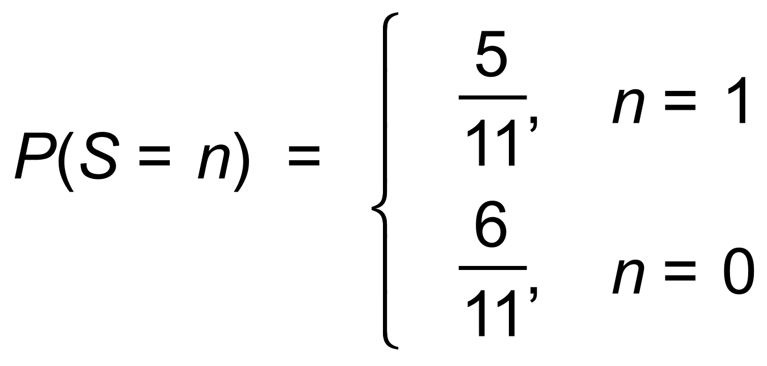 ✓✓✓ [15]

16. (a) 

∴ 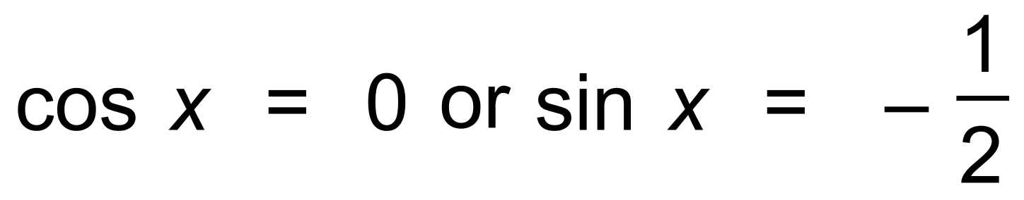

∴ 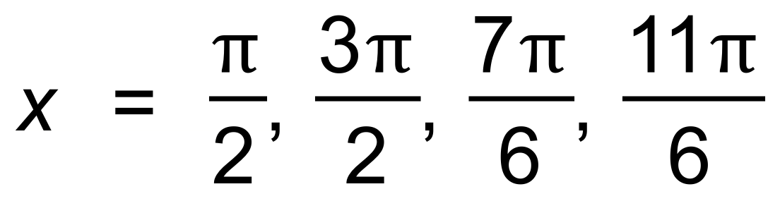 ✓✓

(b) 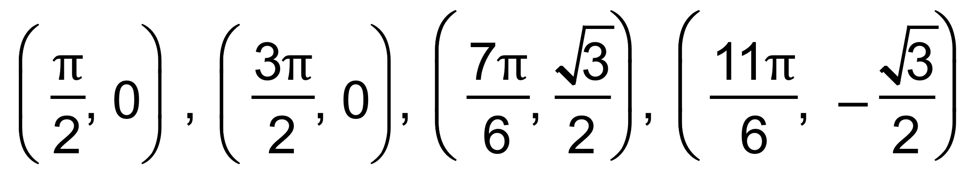 ✓✓

(c) A = 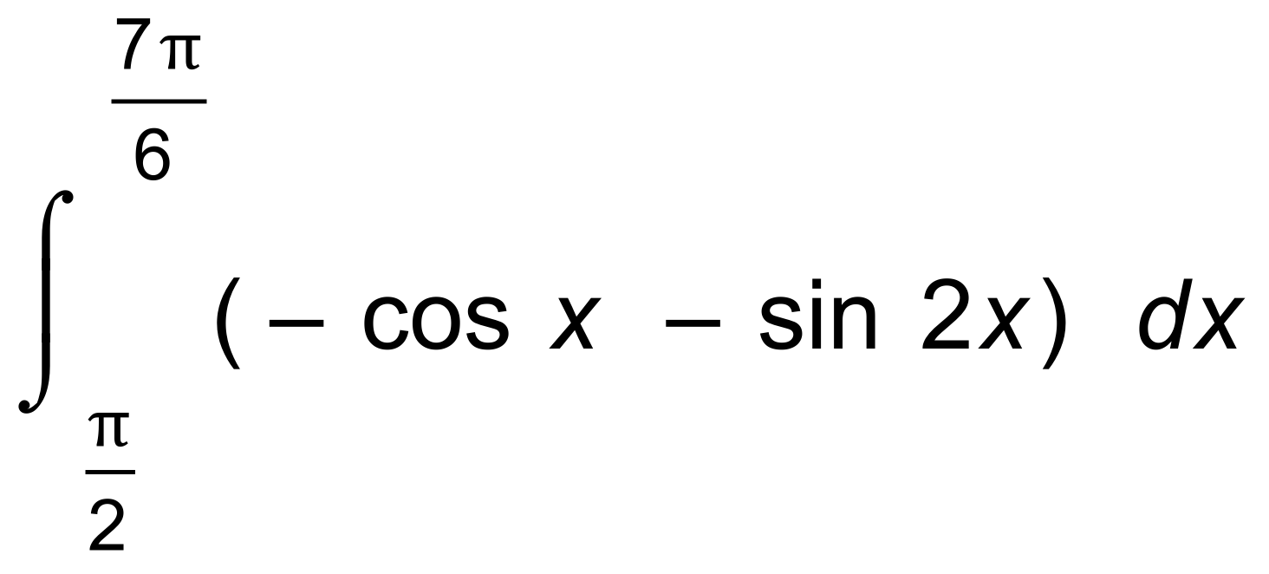 ✓

= 2.25 units2 ✓ [6]

17. (a) 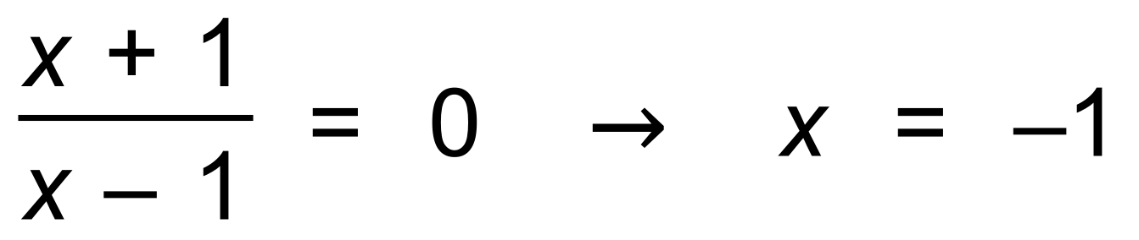 ✓

(b) (i) 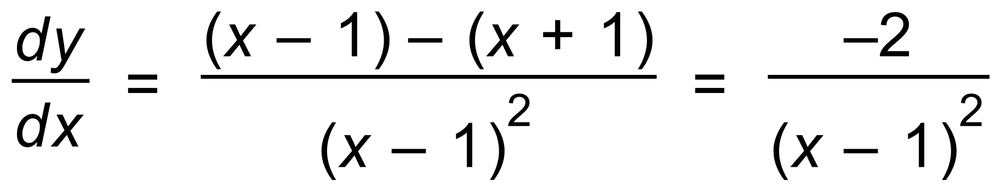 ✓

(ii) True since 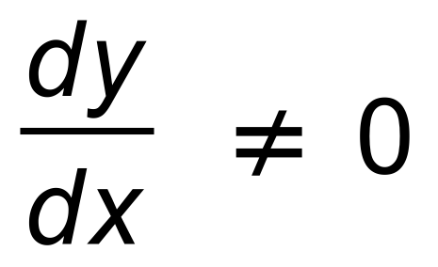 for any value of *x*. ✓

(c) (i)  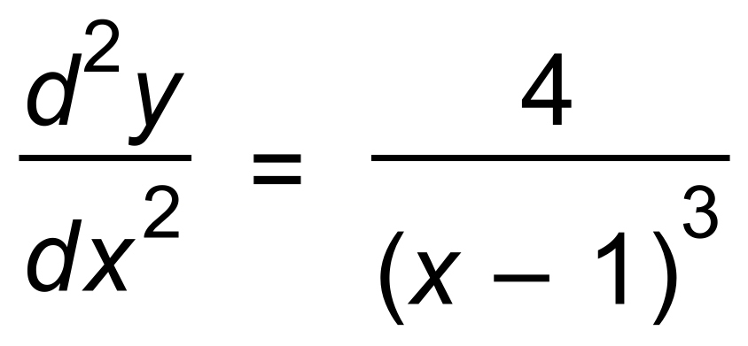 ✓

(ii) True since 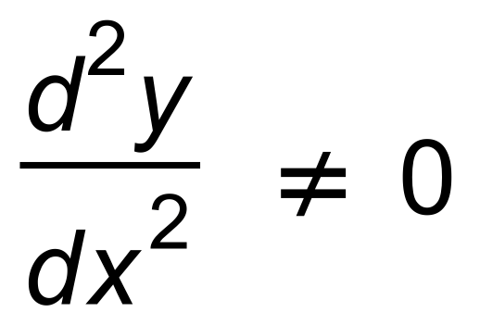 for any value of *x*. ✓ [5]

18. (a) 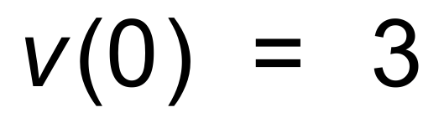 ✓

(b) 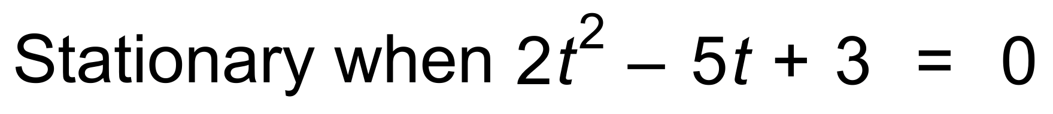 ✓

∴ *t* = 1 and 1.5 ✓✓

(c) (i) 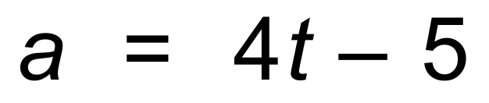 ✓

(ii)  ✓✓

(d) 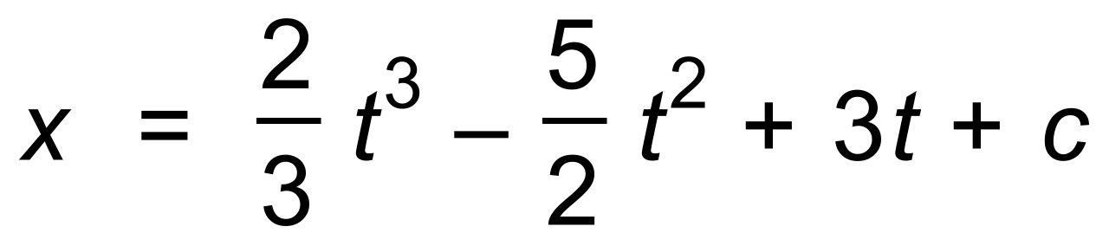 ✓

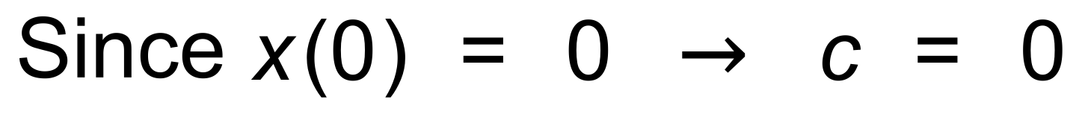

∴ 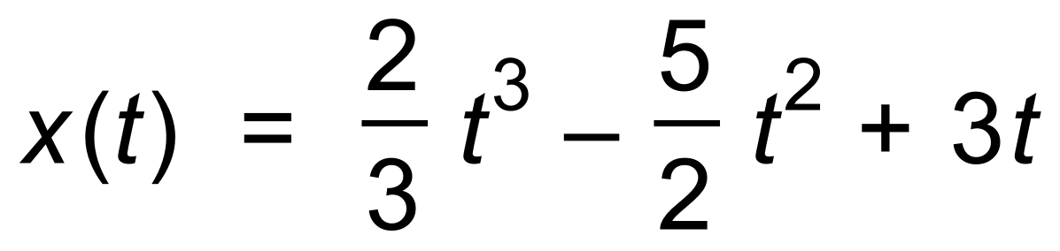 ✓

∴ 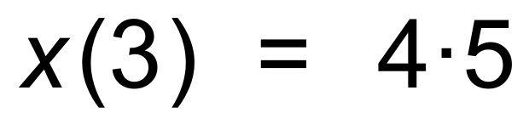 ✓

(e) 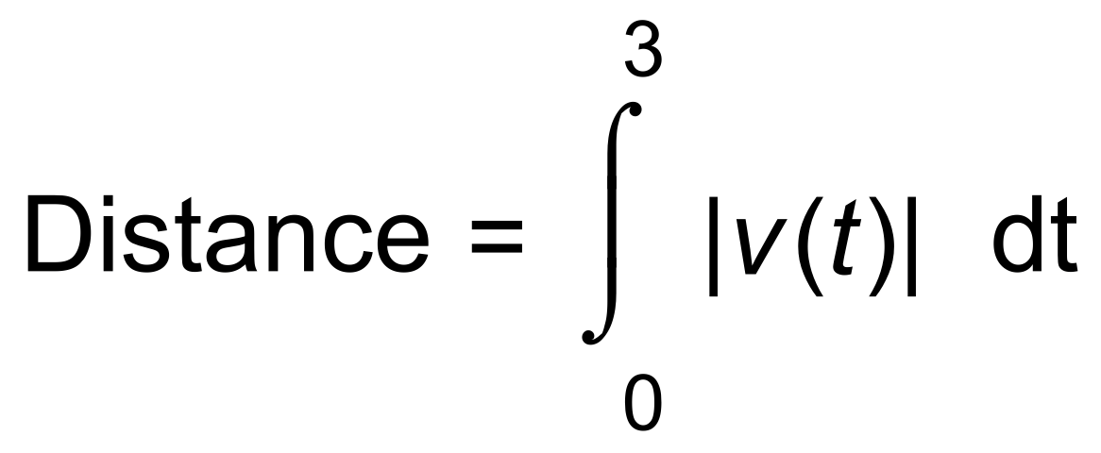 ✓

= 4.58 ✓

(f) Distance travelled ≠ Displacement ✓ [13]

19. (a) 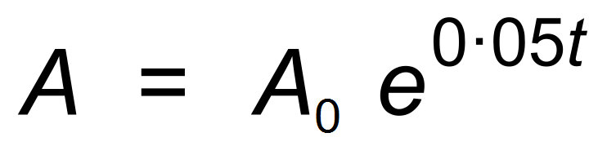 ✓

∴ 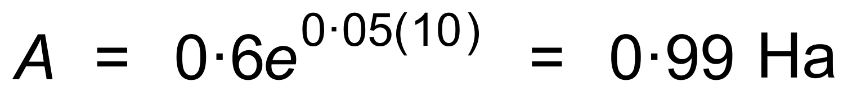 ✓✓

(b) 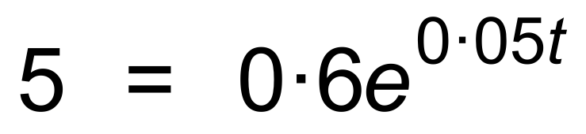 ✓

∴ *t* = 42.4 hours ✓✓ [6]

20. (a) (i) 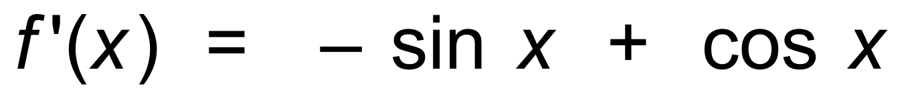 ✓

(ii) 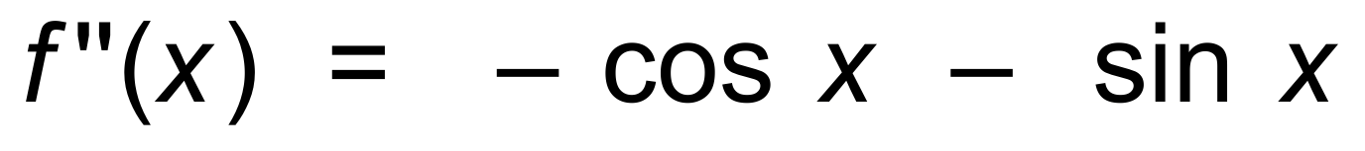 ✓

(b) Maximum value occurs when *f* ′(*x*) = 0

∴ 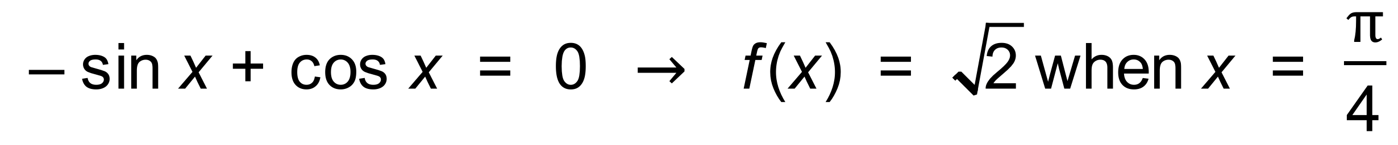 ✓✓

Since  ✓✓

(c) POI occurs when *f* ′′(*x*) = 0

∴  ✓

∴ 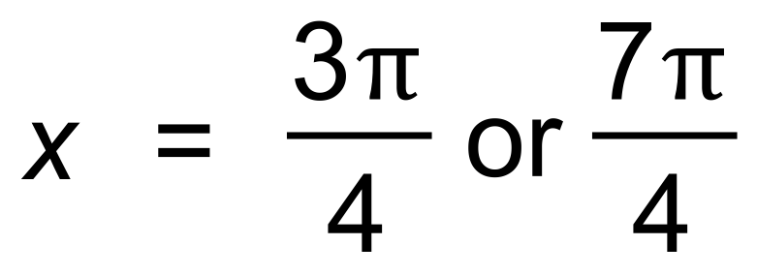 ✓✓

∴ 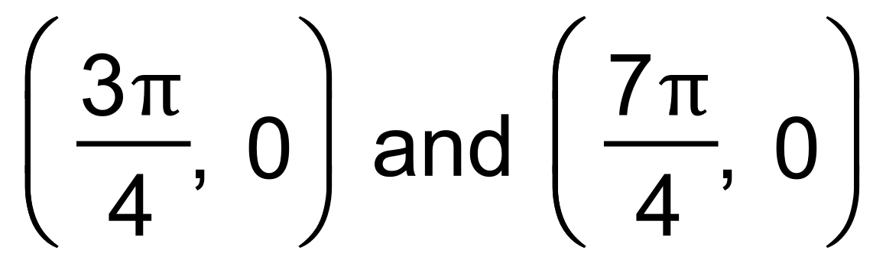 ✓ [10]

21. (a) 10 L/sec ✓

(b)  ✓

(c) 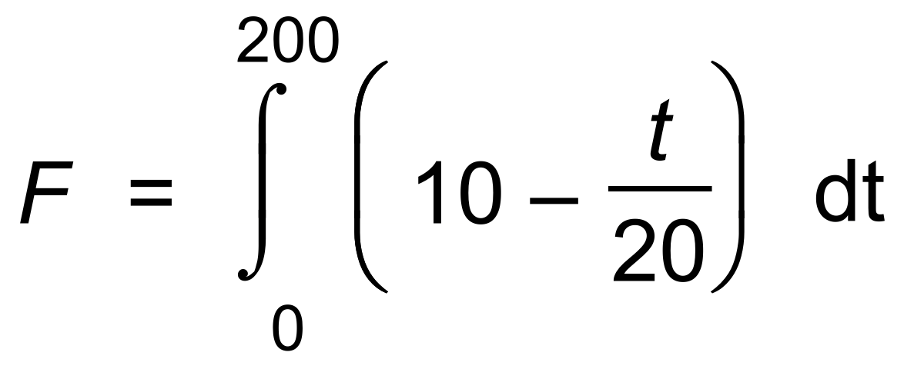 ✓

= 1000 L ✓ [4]

22. (a) 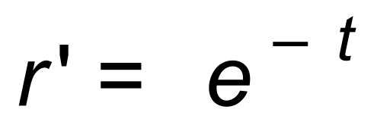 ✓

∴ 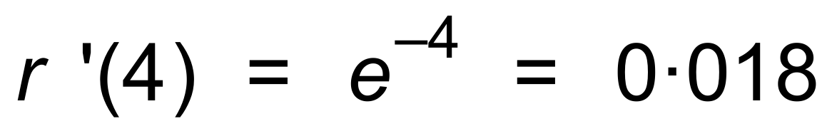 ✓

and 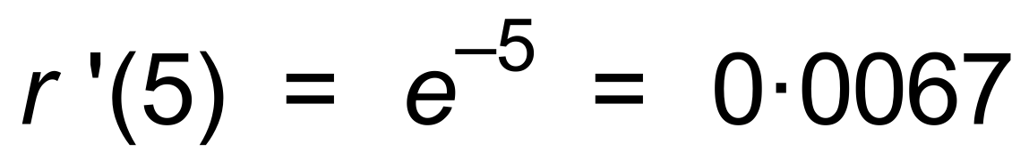 ✓

(b) 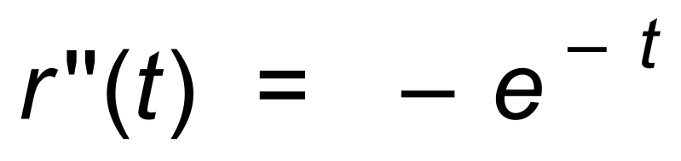 ✓

Since  at its

greatest rate at the start of the fire,

Or the graph has greatest slope at t = 0. ✓

(c) 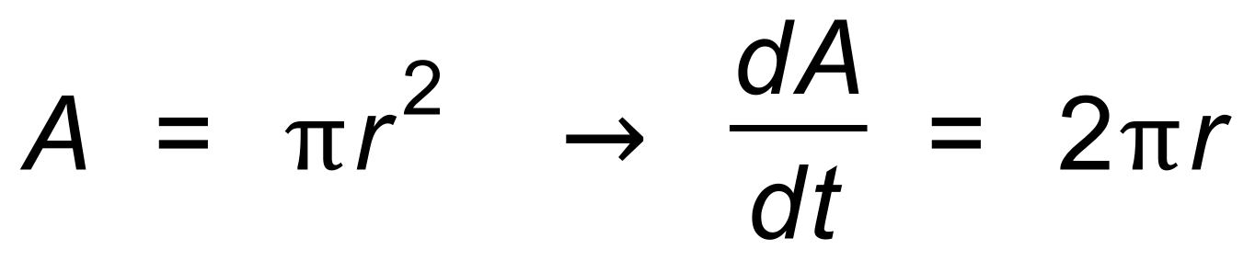 ✓

∴ 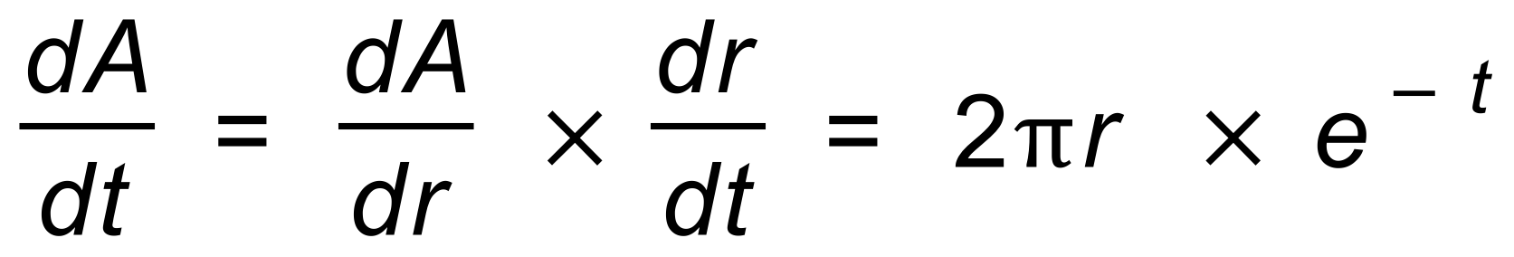 ✓

When *t* = 4 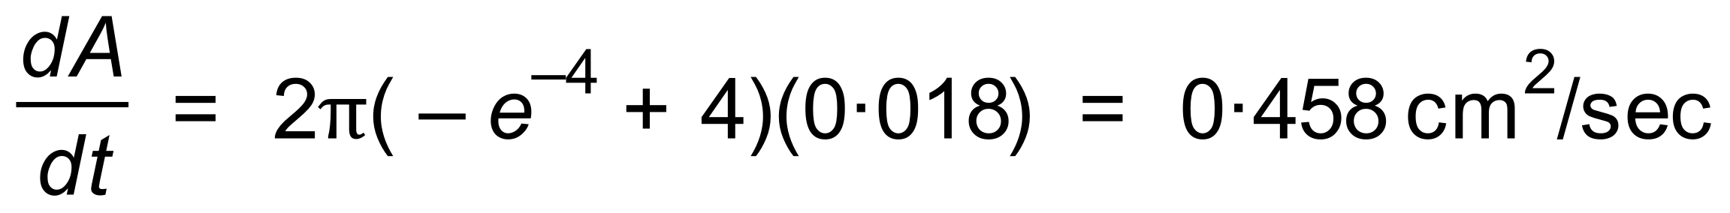 ✓✓ [9]